I/O CABLE

- PARTS:

QUANTITY: PART #: NOMENCLATURE: LENGTH:

1 PER MACHINE 19220-34 CABLE, FLAT RIBBON, 28 AWG, 16 INCHES

2 PER MACHINE 17650- CONNECTOR, 37-PIN, D-SUB, 28 AWG N/A

- ASSEMBLY:

- 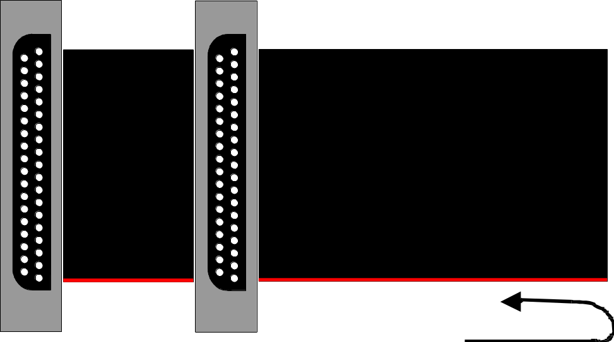ALIGN PIN #1 OF THE CONNECTORS WITH THE RED-STRIPED WIRE, ACCORDING TO DIAGRAM 1.

DIAGRAM 1

